CS 255 System Design Document Template

UML Diagrams

UML Use Case Diagram
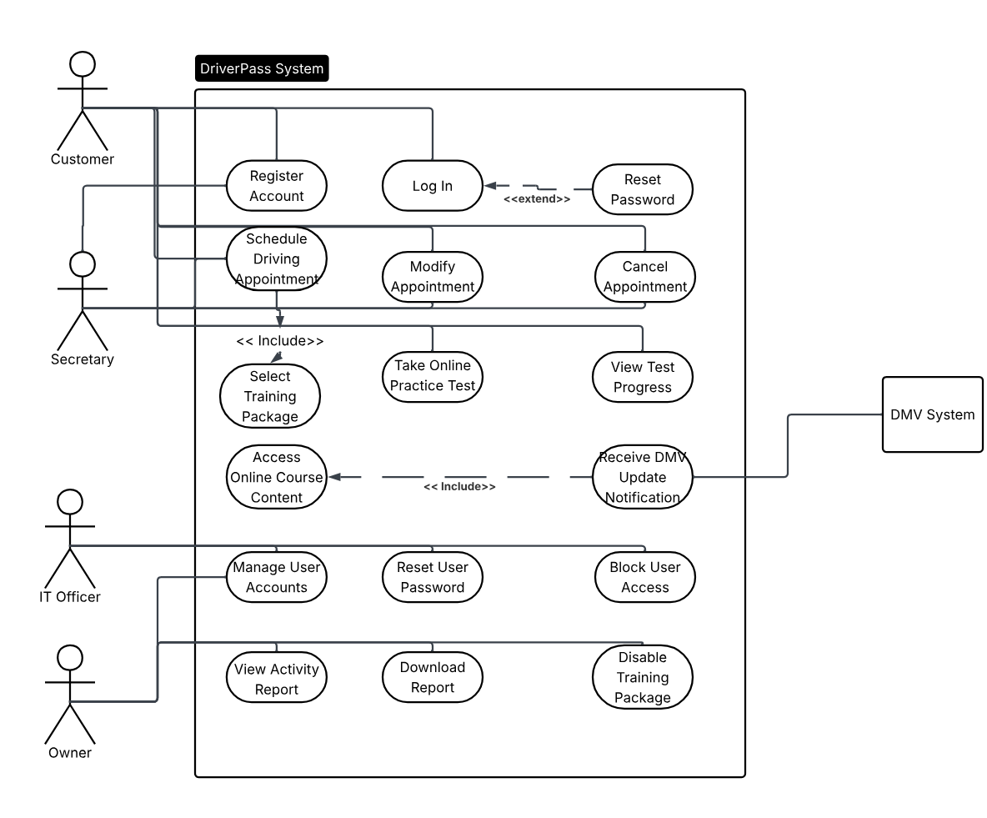

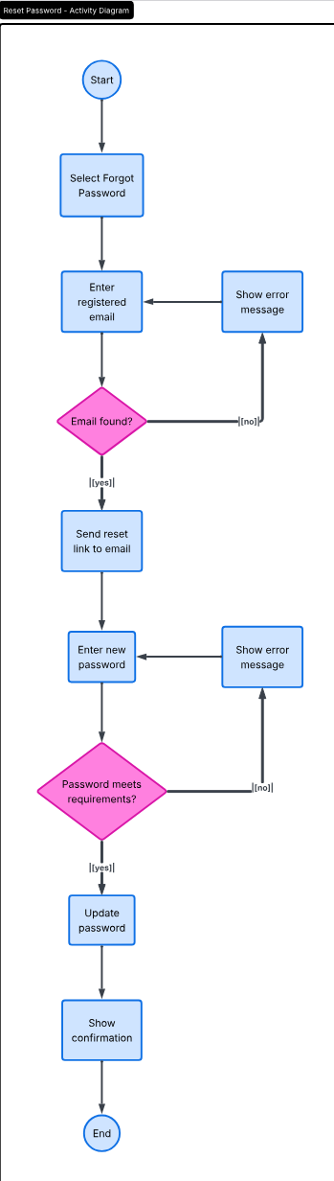
UML Activity Diagrams
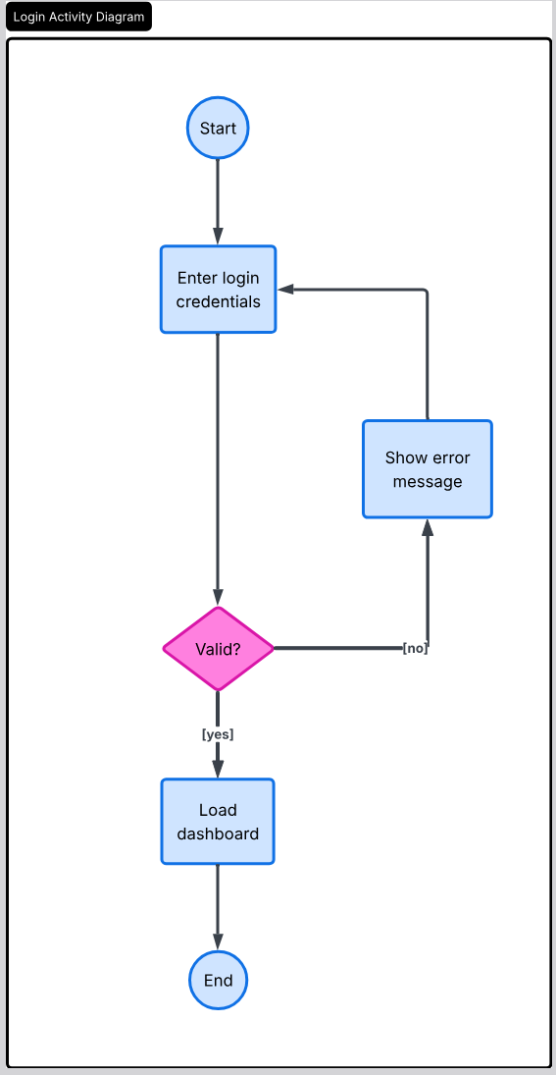

UML Sequence Diagram
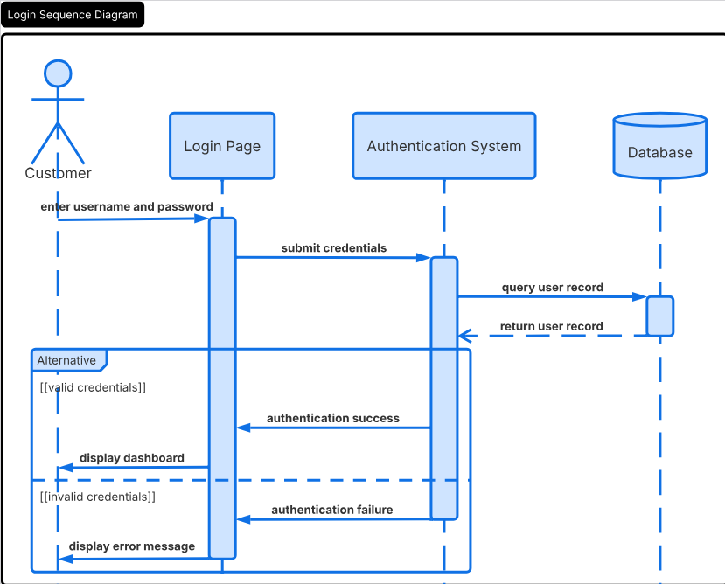

UML Class Diagram
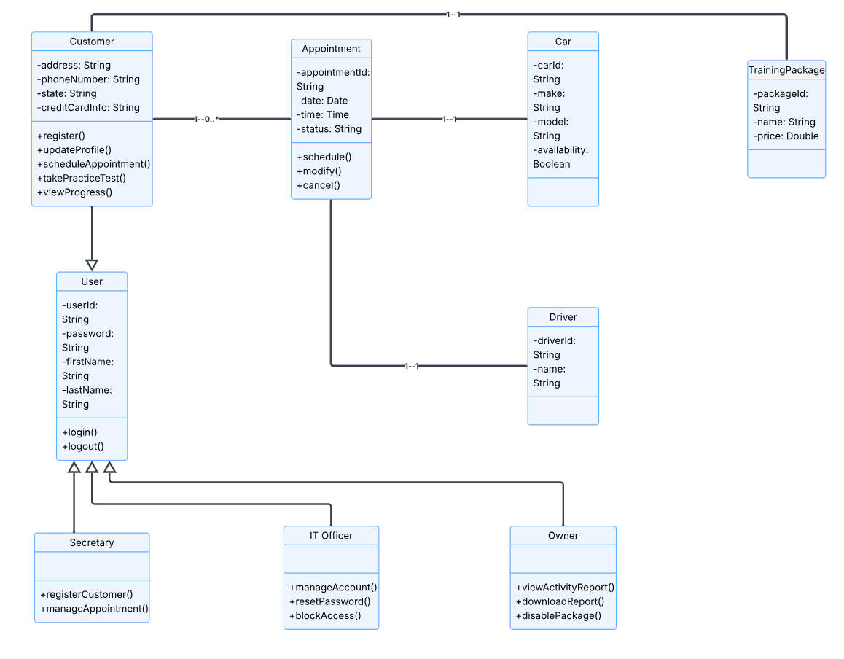

Technical Requirements
- The system requires a subscription or agreement with a cloud-based hosting provider, as there will not be an on-premise server.
- The system should be web-based and accessible through desktop and mobile devices via the internet.
- The system should run on most standard web browsers and therefore be operating-system independent.
- The system requires a database responsible for storing customer data, appointments, etc.
- The system should encrypt all data transferred between it and the customer via HTTPS.
- The system needs to support Role-Based Access Controls. Each user should have a unique username and password, granting them various levels of privileges.
- The system must be able to update rules and regulations in accordance with the DMV via an API or web service.
- The system must integrate with a third-party payment processing network to handle credit card payments.
- The system must store an activity log that tracks all changes made to customer and appointment data.
- The system must have a tool to monitor suspicious login activity, to ensure data security and validity.
- The system should aim for the highest availability and schedule maintenance for off-peak hours in advance.
- The system should be modular, allowing for improved maintainability and function.
- The system database should have consistent backups to prevent a catastrophic loss of data.

